Reception Planning & Resources
(The A-Z Guide)



Finding the Perfect
Reception Location

What exactly should you look for in your reception location, aside from that sense of rightness you know you’ll have the moment you find the most perfect spot? Shopping for a site is like finding a mate, a test you’ve obviously mastered. You should be looking for the same sorts of things like: charm, personality, depth, more than just a pretty face or perfect body (although looks do count!). Take along this list of what to look for from http://www.the-knot.com when you’re ready to go scouting.

* Roomy Fit

First, make sure the room is large enough to accommodate the number of people of your guest list. The space may look very large when it’s completely empty, but not when you factor in the wedding essentials such as: tables, chairs, a buffet, the band or DJ setup, the dance floor, etc... Not to mention your guests, who’ll need some elbow room. Even if you choose an outdoor site, you’ll need ample room on the lawn, or poolside. What’s the best way to assess the size of a site? Ask to checkout the place when another wedding is being set up! Of course, if you decide you must have your wedding at your favorite bar (the one with only one bathroom, two booths, and 4 feet of floor space), you can always work backwards and tailor your guest list to match.

* Privacy, Please!

Privacy varies widely from place to place, as does the importance couples place on it. If you’re having a daytime event in a public location, such as a park or botanical garden, be prepared for strangers to trek past your party. They may even smile, wave, and come by to offer their best wishes. If this is okay with you (the more the merrier!), why not go for the part? If not, opt for a lovely lawn on a private estate, with a nice lake nearby. Or hold the reception at a restaurant or gallery that will post a “CLOSED FOR PRIVATE PARTY” sign.

In addition, don’t think that just because you’re indoors you’re safe from uninvited guests! Banquet halls and hotels often hold more than one affair at a time. If there’ll be other events going on simultaneously in rooms close to yours, your party may be distracted by the harmonious sounds of karaoke-loving guests singing their hearts out the sounds of Madonna through the walls. If this bothers you, try to schedule your reception when there won’t be another one next door. IF this is impossible, visit the site on a dual-party night and see how the sound carries and whether there really are any major people problems before you make your decision.

* Seeing The Light

Light can make or break the mood. If you’re marrying during the day, make sure your halls have plenty of windows. Who wants to spend six hours in a dark room when the sun is shining? If it’s an evening affair, make sure the room’s not too dim - or that the lighting can be controlled for the big entrance, dinner and dancing. If you’re marrying outdoors, say, at dusk, will you be able to set up candles if necessary? Try to visit the site at the same time of day that you’ve chosen for your wedding. Even if the space looks awesome by candlelight, you may be surprised by the sight of that 25 year old carpet during the day!

* Ample Outlets

Be sure to take a thorough cruise around the room to see if it has lots of places to plug things in, especially if you’re partying in a place that is not a regular spot for hosting weddings. Your main user of outlets will be the entertainment crew. Take note of where the outlets are; if their location will force your DJ to spin records in the bathroom, make sure she or he has plenty of extension cords.

* Good Vibrations

If the place is too echoey, it could give some weird reverb to the band, not to mention make it difficult for guests to hear one another talking. A tile or wooden floor, for example, will amplify sounds, while a thick carpet will tend to muffle them. Check out the room’s sound quality during an event. And tailor your music to the acoustic conditions.

* A Place To Park

Make sure the site is near a good parking lot, garage, or big, empty (safe) street where it’s legal to park. If parking is a problem, look for other ways to get everyone to the party. Can a shuttle bus or vans take the guests from the ceremony to the reception? Inadequate parking isn’t necessarily a deal breaker, but it may mean spending more time and money to figure out a viable vehicular alternative.
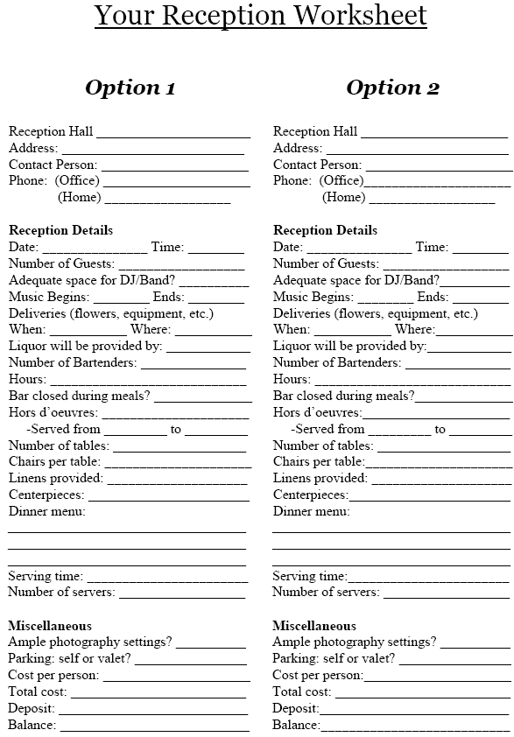
Sitting Pretty: Reception
Seating Made Simple

Your wedding is about a month away. You’ve settled on a reception ball, menu, and table decorations. Now it’s time to sit down and decide where your guests will be seated on your big day. If you are having a buffet, specific seats may not be necessary. But if you are having a seated meal, your guests will be happy knowing they have to fight over a seat when it’s time to eat! And assigned seating lets them enjoy the wedding as much as you are enjoying your first hours as newlyweds. Here are some tips:

- Make a seating chart (use a large piece of paper or the space provided below this page). Draw big circles to represent the tables, dance floor, musical entertainment, and entrances. Then list everyone’s name on an index card or sticky note so you can play musical chairs.

- Place people in spots that suit them. Your friends will want to be near the music, but Grandma and Grandpa will probably be unhappy with the stereo blaring in their ears. Family and friends should be closest to you. Acquaintances and parents’ friends should be farther away.

- A traditional head table is long and straight and faces the other reception tables. The bride and groom traditionally sit front and center, with the maid of honor on the groom’s left and the best man of the bride’s right. But you can stray from tradition. You can have the wedding party and their dates sit at one table, while you and your new spouse have your own small table at the front of the room. You can also sit at a table with only the maid of honor, best man and their dates.

- For family seating, it seems obvious to sit people on the same side of the family together to guarantee that they’ll be comfortable. But you might want to consider sitting the bride’s cousins with the groom’s cousins so they can get to know one another. Regardless, there are always relatives who don’t get along. To avoid embarrassing quarrels, put family members with a history of squabbles on opposite sides of the dance floor - you’ll be happier for it!

- Seating friends allows you more creativity. You can sit people who know each other together or you can play matchmaker by seating people at the same table who’ve never met before this occasion.

- Sometimes, there are just some people who don’t fit in anywhere… Your friend from camp, your third cousin who’s in the circus. Whatever the case may be, avoid seating all the random guests at one table. They’ll know they’re the outcasts.

Reception Seating

Use the space below to draw the floor plans of your reception hall. Be sure to leave room so you may write down your seating arrangements.


Choosing The Right Caterer
For Your Reception

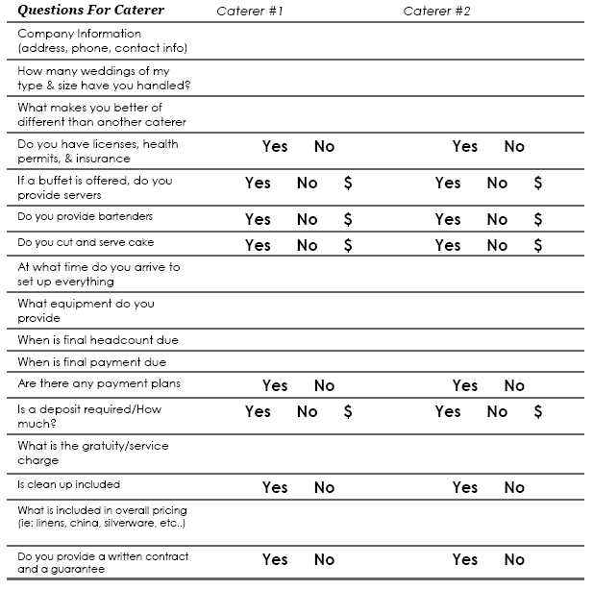
The Wedding Cake

The bride and the groom may be the stars of the big day, but the wedding cake definitely deserves a nod for it’s time honored, supporting role.

In ancient Rome, guests broke a wheat bun over the bride’s head to bring good luck and fertility. Fortunately, the buns sweetened up, and in the 17th century, a creative French baker stacked and frosted them! The very first tiered wedding cake was born.

* Cake Bake Off

White cakes, butter cream frostings, columns and dazzling sugar flowers are wedding cake classics, but feel free to break away from tradition. If you prefer a trendy design, try a colorful southern red velvet cake, a mango creation that boasts Caribbean flair or even an Asian inspired creation with red frosting.

As colors go bolder, style and form are also changing. Askew cakes, whose tiers are placed off center, are gaining popularity. Even wilder, Krispy Kreme, a popular donut chain, has seen a number of requests for multi-tiered cakes made entirely of the donuts - one for each guest. Krispy Kreme Executive Chef, Ron Rupocinski, has created several templates so brides can choose the look that best fits their reception.

* Beyond The Taste Buds

So what’s on top? Joining the ranks of the plastic couple, new toppers are simple and design oriented: a slim, petite vase with a single rosebud, a layer of flower petals, a plain tiny top tier. Family is in, and
some couples are choosing a portrait of themselves, a sentimental keepsake like a key chain, or their initials that can be sculpted into shapes.

Cake presentation is also an important aspect at the reception. What’s surrounding your cake is just as visible as the cake itself – especially in photos - so plan ahead! Possible cake surroundings include a nature inspired display of twigs spread on the table, baby photos of the bride and groom or a handmade tablecloth from Grandma.

* Cake Mistakes

Cakes are a beautiful addition to your wedding, but sometimes they can go terribly wrong. Here are several “do not’s” to keep in mind:

- Do not frost with butter cream at a summer wedding unless you want sticky hands (the icing melts extremely quick).
- Do not put your cake in front of a bathroom or distracting wall ornament. It deserves center stage.
- Do not Forget to cut it with a knife suited to the cake’s composition of texture.
- Do not forget to talk with your florist about safe, edible blooms if you intend to have your wedding cake decorated with fresh flowers.
- Do not let the photographer take distant photographs of your cake. It’s an important part of your ceremony, so get up close to capture the details!

* The Cost Of The Cake

Designing the perfect dessert can leave you with a not-so-perfect budget. Save money with your cake by following these tips:

- Have a small cake to cut in front of guests, while pre-sliced sheet cakes (or cute bakers’ cupcakes) wait in the back to be served.
- Not everyone will eat cake! Subtract 10 people from your guest total when calculating the slice count.
- Use fresh flowers or fruit garnishes and your own supplies as cake decorations to avoid handicraft fees from the cake designer.
- Skip a separate dessert - your wedding cake is enough.
- Serve half slices and enhance the plates with fresh fruit or sorbet.
- Forgo the fondant. Butter cream icing is less expensive (and tastier!).

* Cake Details

Give your baker as much notice as possible. Order your cake at least six to eight months in advance. Grocery store bakeries may require less notice. Your baker will need to know how many people the cake will serve, as well as flavor and decorating preferences. You may also be asked about your wedding colors and flowers. Be sure to get a receipt for your deposit, and do not forget to ask about delivery information, the balance due and if there is a contract involved.

